UPMA Wisconsin Chapter
CONVENTION STANDING RULES
1. For admission to the assembly hall, to facilitate identification and seating, members shall be required to wear the badge issued by the Credential Committee upon registration.
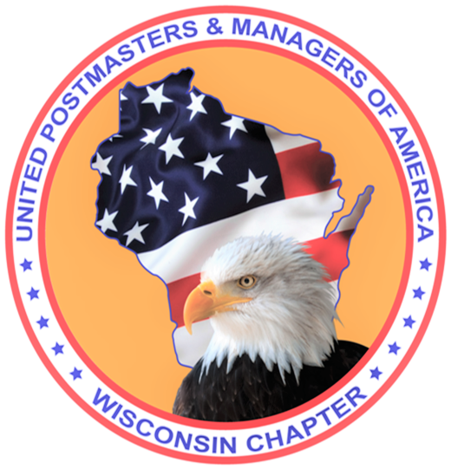
2. Debate on any motion shall be limited to a maximum of twenty minutes, ten minutes each allocated to proponent and opponent, who shall be recognized on an alternating basis.
3. No member shall debate or speak more than once on the same question, unless no other member is seeking to be recognized on the question. No member shall speak more than five minutes on a question.
4. Candidates for national office, or their designee, will be permitted ten minutes floor time to speak on their behalf.
5. Floor time for endorsements and seconding speeches will be limited to ten minutes.
6. These rules may be suspended by a two thirds vote of this convention.

2024 Wisconsin Executive Board
President Melissa Tarlton
Shawano WI 54166
920 438-9480 (c) 920 598-1180
melisstarlton@gmail.com

Ex- Vice President (Membership) Dean Miller
Westfield WI 53964
920 296-4386 millerdean7@yahoo.com

Vice President (Legislative/PAC) Joan Baumgart
920 572-0297 jngbaumgart@wolfnet.net

Vice President (Education) Pamela Ritchie
N.C.E.D.
920 268-7183 pastorpamla08@aol.com

Secretary/Treasurer Julie Erdmann
262 949-1782 Juliea@elknet.net

Editor Website Administrator Rick Dama
262 719-1267 radpm3262@gmail.com

Past President / Member Rep. Chair Laurie Bue
612 720-8047 redgizzy555@gmail.com

Member Rep. Jeannie McLaughlin
847 529-8067 jeannie9966@sbcglobal.net

radMember Rep. Nancy Ackerman
Thiensville WI 53092
262 242-0955 414 544-7234 nortoniii@yahoo.com

Member Rep. Scott Hughart
Mauston WI 53948
309 826-7254 shughart2011@gmail.com

Parliamentarian Bill Tierney
608 697-5920 wctierney@charter.net

Scholarship Chair, Chaplain,
Margaret Szymanski
608 296-3653 richi@palacenet.net

Convention Chair Jim Woodcock (Woody)715 864-1011 jewoodcock123@icloud.com

Memorial Service Chair Linda Hobbs
715 435-3267 clhobb@wctc.net

President Retirees Pauline Colamatteo
608 434-0647 pncola@tds.net

Executive VP Retirees (Membership) Galen Freymiller 608 822-6830 galenfreymiller@yahoo.com

VP-Retirees Bill Tierney
608 697-5920 wctierney@charter.net

Sec/Treas Retirees Marianne Zarling
920 420-3826 pm54947@gmail.com

2024 UPMA
Wisconsin Chapter
8th Annual Convention
29 Pines Convention Center
Sleep Inn & Suites Hotel, Eau Claire

Friday April 26th
through
Sunday April 28th 2024

Tentative Convention Agenda 2024
(subject to change)

Friday April 26, 2024
9:00 am Executive Board Meeting

12:00 pm Registration / Vendors Open

12:30 pm Transportation leaves from hotel lobby for Leinenkugel Brewery &
River Bend Winery tasting tours
1:00 pm Golf – Mill Run Golf Course (tentative)

1:00-5:00 pm Training for Active Members- on the clock (No Loss-No Gain)
with manager approval
1:00 pm SWC’s/PS150/Q&A with Linda Naranjo,
Manager Workforce Planning-WI District
2:00 pm Postal Service Health Benefits Program (PSHB) starting in 2025 with Karla Kirby, Compensation & Benefits - Headquarters
3:00 pm Voyager Recordkeeping/Audits/Q&A with Dawn Johnson, Berlin Postmaster/
Postmaster Essentials Facilitator
3:00 pm PSHB for retirees, with Karla Kirby
4:00 pm Retirees welcome to join
Jeff Drake, WI District Manager

1:00-5:00 pm Hospitality Room
(open to all UPMA members and family)
5:30 pm Cash bar
6:00 pm DINNER
6:00 pm DJ – Tom Kelley
7:00 pm Silent Auction begins
7:00-11:00 pm Meet & Greet
Dress with Disney character themed costumes (earn extra tickets for fabulous prizes) & games
11:00 pm-1:00 am Hospitality room open
Saturday April 27, 2024

Breakfast on your own
Registered Hotel guests-
Complimentary Breakfast in hotel lobby
8:00 am – 5:00 pm Registration / Vendors
9:00 am Business Session 1
Invocation
Color Guard - Colors presented
Pledge of Allegiance/National Anthem
Welcome - President Melissa Tarlton
Introductions of Executive Board Members
Announcements/Credentials
Parliamentarian - standing rules of convention
Convention Chair report
First Timers Report
Reading of 2023 WI Chapter convention minutes
Nominations WI Chapter Board Positions
National UPMA Board Representative
Voting information:
National Officer Candidates
National Board recommendations to the National Articles of Incorporation/Bylaws
Reading of WI Chapter Article/Bylaw recommendations
10:30-10:45 am BREAK
(Nominations Committee will take nominations 10:30-10:50)
11:30 am UPMA Nominations Committee
Nominations Committee
report ballots/ voting
WI Chapter Nominations, Bylaws, and Articles of Incorporation
Announcements
Business Session Adjourns
12:00-1:00 pm LUNCH
1:00 pm Business Session 2
Vendor Introductions
2:00 pm Sec/Treasurer Report
Adverse Action Report

VP Membership, Education
and Legislative/PAC Reports
2:30-2:45 pm BREAK
2:30 pm Retiree Meeting - Rejoin w/ Active members following meeting
2:45 pm Elections /Voting
3:00 pm RREC’s/Rural Adjustments/Q&A
with Melissa Tarlton, Shawano Postmaster/
Unfinished Business/ New Business
Announcements
Business Session Adjourns
3:00-5:00 pm Hospitality room available
5:30 pm Cash bar
6:00 pm Grand Banquet
UPMA Scholarship Awards
Break 15 Minutes
Silent Auction ENDS
UPMA Member of the Year
Silent Auction Items Awarded
Following: DJ/ Games / FUN for all until Midnight
Midnight – 1:00 am Hospitality room available

Sunday April 28, 2024
8:00 am Registration
8:15 am Memorial Service
8:45 am BREAKFAST
9:15 am General Session
Veterans Recognition
Swearing in of Officers,
National UPMA Board Rep.
First Timers Report
Convention Chair Report
Announcements/Credentials
Grand Prize Drawings
(must be present to win)
Closing Prayer
Adjourn Convention

SELF GUIDED TOURS OF EAU CLAIRE

